## Create a new Windows based Virtual Machine (VM)

Contents

Create a new Windows based Virtual Machine (VM) 1

Create a new Windows based Virtual Machine (VM) 2

Credits 17

## Create a new Windows based Virtual Machine (VM)

In this article, we will use an ISO installation of Windows Server 2016. However, the process is similar for any Windows based installation.

First, click on the **File** menu and select **New Virtual Machine** to launch the VM creation wizard.

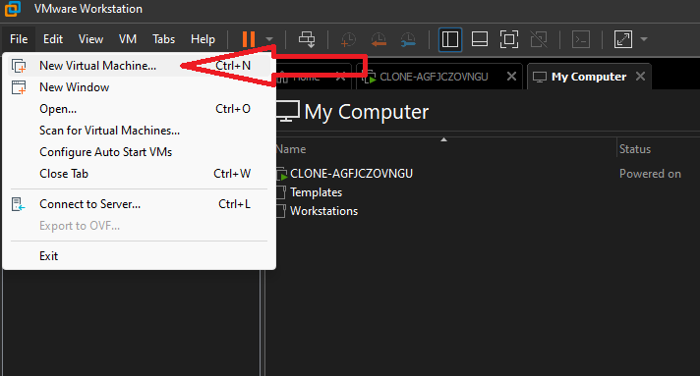

In the window that opens, you will need to choose between **Typical** and **Custom** settings for the VM you will create. In our case, we will select **Custom** which gives us somewhat more flexibility in the following VM settings. To learn the difference between Typical and Custom Customizations see [HERE](https://docs.vmware.com/en/VMware-Workstation-Pro/16.0/com.vmware.ws.using.doc/GUID-BCCF51D0-B76C-433A-A376-FEAEC12C52B5.html?hWord=N4IghgNiBcIG4FsDuYBOBTABEg9qg1gM4AuYxAljgHaYCMA7JgMroToDGFVA5pmJgDVyqYgFdImALJh2AC3JUsAYWoAzct1GoylKiAC+QA)

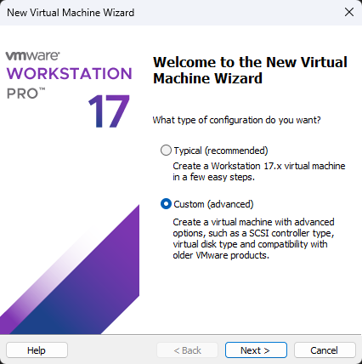

Then choose hardware compatibility with VMware Workstation versions. If you are not going to use VMs that require a specific version of the Workstation then leave the **12.x version** selected and click **Next** to continue.

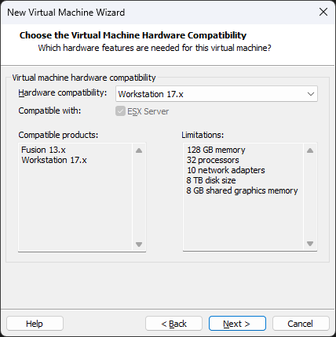

At this point, you can select from which media the installation of the operating system will proceed. If you select the **Installer disc image file (iso)**, VMware Workstation will recognize the version of the operating system and will prompt you to proceed using the Easy Install procedure. More about Easy Install [**here**](https://docs.vmware.com/en/VMware-Workstation-Pro/12.0/com.vmware.ws.using.doc/GUID-59676FB4-4EA8-4C2D-812D-05008B8CCA50.html?hWord=N4IghgNiBcIKZgM4E8AEBLAdogLpKAvkA).

In our case, I will choose **I will install the operating system later**, allowing us to create a blank disk and later select which operating system we will install. Click **Next** to continue.

In the next step, since we have not selected an ISO installation, we will be asked to choose which operating system to install. In this case, select **Microsoft Windows** and Windows Server 2016. Click **Next** to continue.

Next, type a name for the VM to create as well as the storage location of the VM files. It is a good idea to create a dedicated folder on your computer for all VMs and create a new separate folder for each VM separately. However, this is at your own discretion and depending on your own configuration of your virtual lab.

Choose between **BIOS** or **EFI**, depending on the type and testing you want to do on your VM.

Select the number of processors and cores that the VM will have.

Select the available RAM that the VM will have by typing a number in the corresponding field or moving the pointer.

Select the type of network that will use this VM between Bridged, NAT, Host-Only Networking. The most basic setting is NAT that automatically gives access to the Internet after the first boot of the operating system.

Select the I / O type for the SCSI controller. Depending on the operating system you are about to install, some options may not be supported.

Choose the type of virtual disk, the preferred option is **SCSI**. Or NVME if you have ssd disk

Choose whether to create a new virtual disk or use an existing one (virtual or physical). Since it’s the first VM you create, choose **Create a new virtual disk**.

Select the size of the virtual disk (in GB), and then create it as a single store file (Store virtual disk as a single file) or a multi-file store. Also, enabling **Allocate all disk space now** means that the virtual disk that will be created will immediately occupy the entire space you chose, so turn it on only if you already have enough free disk space. Otherwise, the virtual disk will gradually expand as new data is added.

Select the name of the virtual disk (and its complementary tracks). As a storage location, you can leave the default one in the same folder as the other VM files.

Finally, clicking the **Finish** button will complete the VMware Workstation VM creation process. At this point, you can see a summary of the settings you chose in the previous steps. Also, by clicking on the **Customize Hardware** button, you can customize the hardware part of the VM, for example by modifying the RAM, adding more disks, network adapters, etc. However, all these can be done later.

Did we forget something? Yes, the operating system.

In the previous step, we chose to declare the installation ISO after creating the VM, so it’s time to do it now.

Right-click VM (or from the **VM** menu) and then **Settings** to open the VM settings window.

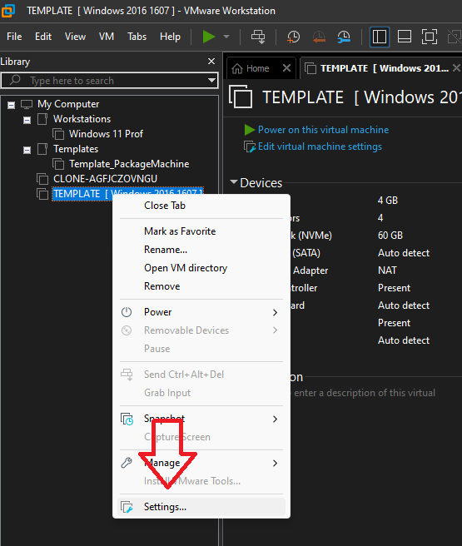

Go to the **CD / DVD (SATA)** section of the **Hardware** tab. Here, make sure that **Connect at power on** is enabled. Then select the **Use ISO image file** option and then select the installation ISO by clicking the **Browse** button.

That’s it! Now, you are ready to start the new VM for the first time by tapping **Power on this virtual machine** or the corresponding icon and then proceeding to install the operating system you chose.

## Credits

This document is based on the following guide.

All credits go to : **Dimitris Tonias**

<https://www.dtonias.com/create-windows-based-vm-vmware-workstation/>